TC-VER-001
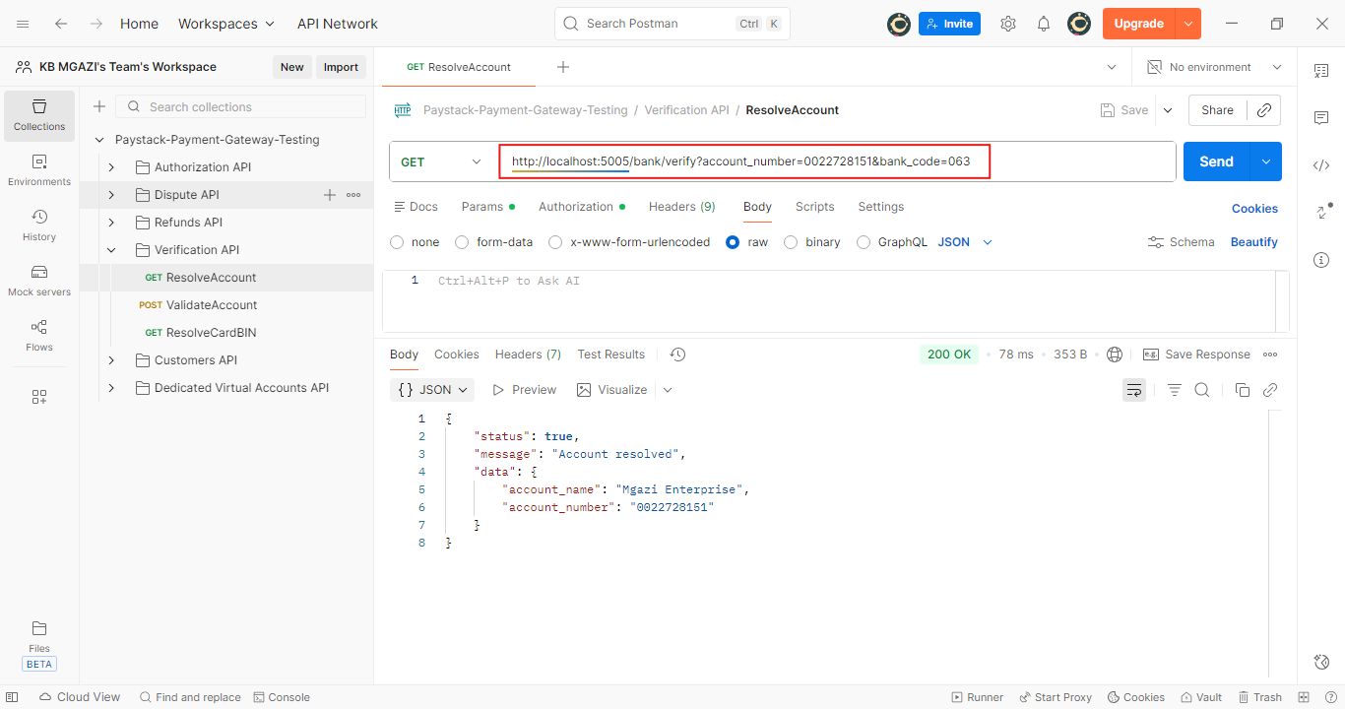
Response:
{
"status": true,
"message": "Account resolved",
"data": {
"account_name": "Mgazi Enterprise",
"account_number": "0022728151"
}
}

